**I MCA-II SEMESTER**

**OBJECT-ORIENTED PROGRAMMING LABORATORY**

**ASSIGNMENT-3**

1. How to display string in a rectangle?(dispstring)
2. design a national flag using GUI(national flag)
3. WAP to Design An Applet For Recording The Student(as3,as3h)
4. WAP to display digital clock using Applets.(Digital Clock)
5. Program to create GUI for Bank Account Simulation(Bank)
6. Creating A Simple Calculator to Handle Button Events(as6)
7. How to display a pie chart using a frame?(pietest)
8. WAP to create a class component that show controls and eventhandling on that controls. (math calculator).(same as q6)
9. WAP to draw the line, Rectangle, oval, text using the graphics method.(as9)
10. WAP to create a Menu using the frame.(as10)
11. Write an MouseEvent Program to display following for mouse events. When mouse is clicked a small circle is drawn. When it is pressed a big circle is drawn
12. When mouse is clicked a circle (radius 70) is displayed. The center is the place of click.(as11i)
13. Circle when mouse pressed. Rectangle when mouse released. (as11ii)
14. Circle when mouse released at the place where the mouse was pressed. (as11iii)
15. Line when mouse is released. The end points are places of mouse press and release. (as11iv)
16. Rectangle when mouse is released. The end points are places of mouse press and release.(as11vvivii)
17. Assume that location of mouse release is east south of the place of mouse press. (as11vvivii)
18. Do above problem, when no such assumption is made. (as11vvivii)
19. Circle when mouse is released. Centre is the place of mouse pressed. The radius is the distance between mouse pressed and mouse released. (as11viii)
20. Circle when mouse clicked.
21. The location is the place where the mouse was previously clicked. (as11ixa)
22. The location where mouse was clicked two steps back. (as11ixb)
23. Line is drawn from the place of mouse pressed to mouse dragged. (as11x)
24. Line is drawn from the place of mouse pressed to mouse released.(same as 11iv)
25. All such lines are displayed.(same as 11iv)
26. Initially a large number of rectangles are displayed. Their north west corners are (5,10i)

i=1..30. Their length and breath are 100 and 8 respectively. When mouse is clicked

inside a rectangle then it disappears. (11iii)

1. Initially a large number of circles (radius 20) are displayed. Their centers are (5,40i)

i=1..15. When mouse is clicked inside a circle then it disappears. 14. Initially a large number of circles (radius 20) are drawn. Their centers are (0,0),(50,0),(100,0), ...

(500,0),(0,70),(50,70),..(500, 70),(100,140),..(500,140),..,(500,700). When mouse is

Clicked then nearest circle is removed. (11iv)

1. Do above problem when a circle disappears when mouse is clicked inside it. (11v)
2. Write an KeyEvent Program to perform the following operations.
3. Write a program to enter string through the key board. (as12i)
4. Modify above program so that old string vanishes when ENTER is typed. (12ii)
5. Modify above program so that output is updated after typing every letter. (12iii)
6. When circle is typed then a circle is drawn. (as12iv)
7. When “circle 10” is typed then a circle of radius 10 is drawn. (as12v)
8. When “circle 30 40 10” is typed then a circle of centre (30,40) and radius 10 is drawn. (as12vi)
9. When “circle red” is typed then a circle of red color is drawn. (as12vii)
10. When circle is typed then circle is drawn. When rectangle is typed then rectangle is drawn. And so on. Also specify their parameters. (as12viii)
11. When F1 is pressed a circle is drawn. When F2 is pressed a rectangle is displayed. (as12ix)
12. When 5 is typed a circle of 50 is displayed. When 7 is typed a circle of radius 70 is displayed. (as12x)
13. A cursor is displayed. It can be modified using arrow keys.
14. WAP to create a Dialogbox. (as13)
15. WAP to Implement the flow layout And Border Layout.(as14,as14ii)
16. WAP to Implement the GridLayout, CardLayout. (as15,as15ii)
17. WAP to demonstrate System clock.(DigitalClock)
18. WAP to create Frame that display the student information(as3,as3h)/(as17)
19. Create or Make Simple Tic tac toe Swing based Gui Java program.(game)
20. how to create a cartoon on applet and performs its event handling.(cartoon)
21. Create an City Map Applet. The applet shows the map of a city from top angle with five buttons, namely, Hospitals, Shopping Malls, Police station, Post Office, and Stadium. If a user presses the Hospital button, all the hospitals are shown on the map with a specific color and likewise for Malls, Police station, Post office and Stadium.(as20,as20h)
22. Create an applet that looks like this: (as21,as21h)

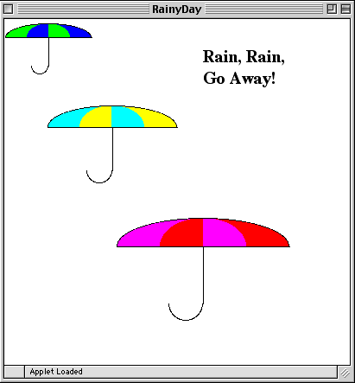

1. Write a Java program that draws the following output using a for loop.(as22)

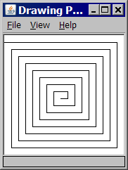

1. Write a Java program that draws the following output using a for loop. (as23)

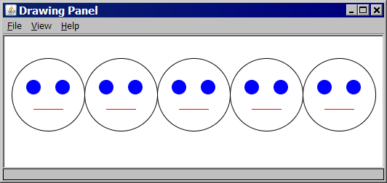

1. Write a Java program that draws the following output.... Just kidding!(pattern)

